Flyer Template Instructions

Font:
Attached is a zipped file called “Open Sans”. This is the font file for Microsoft Office products—these fonts must be loaded on your machine for MS Office software to render properly. You can either install them yourself, or get your IT person to install them for you. The only font that should be used in your presentation is Open Sans and it’s style options (light, italic, etc.)

- Launch the Word Template.

- Name and save your document: File> Save As>

- Page Header: to change the type and add your header , View> Header and Footer> Type over “Page Header text.”

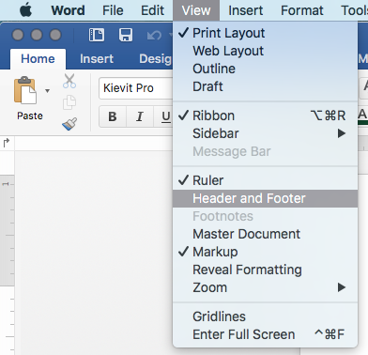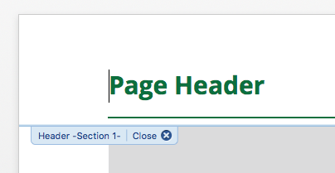

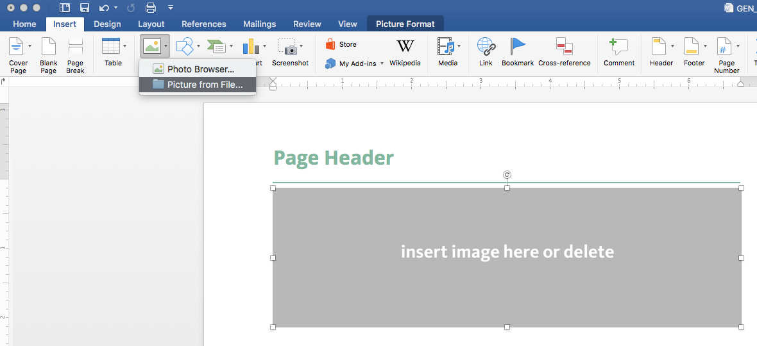
- Top Image: With the gray box with the text “insert image here or delete” Go to the Insert tab Pictures icon and scroll to Pictures from File> to select a photo to replace the box. Or simply delete the gray box if you do not have an image. The box will automatically adjust to accommodate the ratio of the photo. This may create an additional page in your document. (see step 5 to eliminate this page.)

- Second Page: When placing your photo at the top, your document may have created a page after page one that has the same header and footer as the first page. Simply copy and paste the content from page 2 onto page 3 and it will automatically remove the third page and leave you with the page that just has the “O” on the bottom.

- Choosing Type Styles: You can type over the mock up text in the document or, In the Home tab, you should see a bar across the center of the top displaying the type styles that are available and labeled what they are used for:

- Adding photos with captions: From the Insert tab then click on the References tab and select Insert Caption icon: Caption will say “Figure 1” after you click OK.

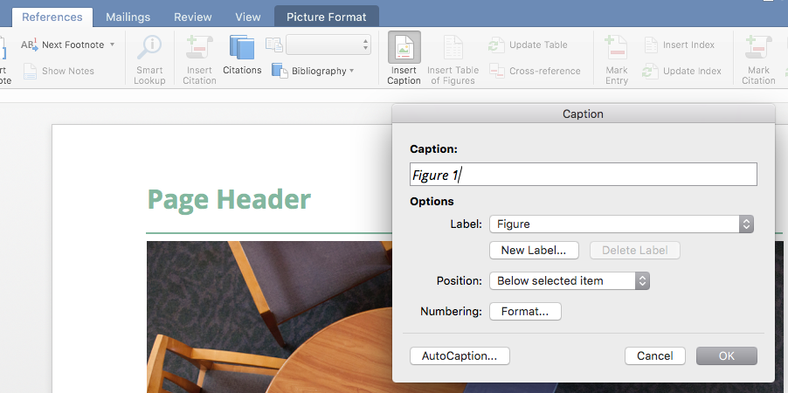

You can now type directly in the caption box and change the text:
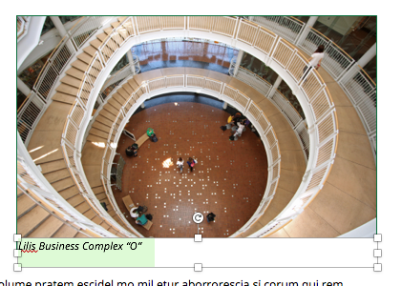

- To create a text wrap around a photo: After inserting a photo, click on the Picture Format tab, then the Wrap Text icon and select the type of wrap you desire. You can drag your photo around to place it where you want the text to flow around it.

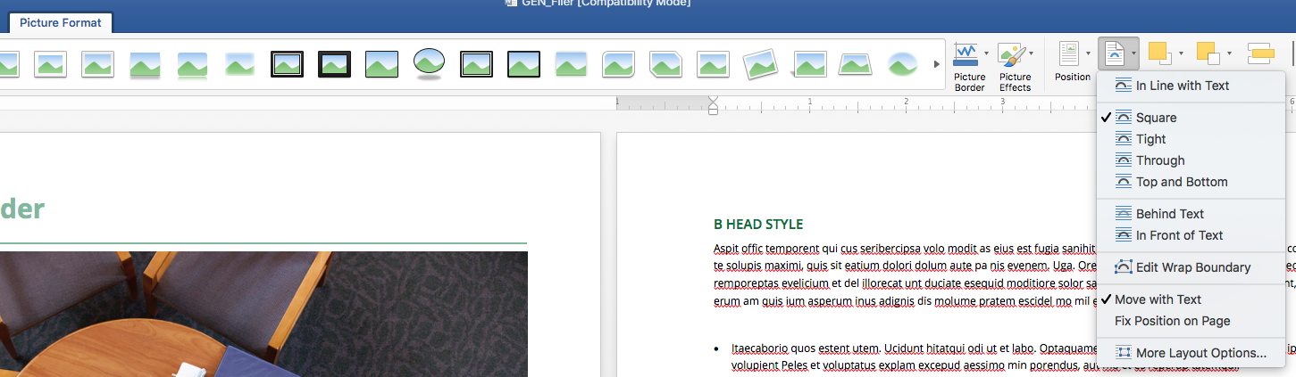

Created by: Mikayle Stole, Oct. 27, 2017

Revised by:

